

FRONT-END DEVELOPMENT
HACKATHON – Level-2 (Interactivity Implementation)

STUDENT NAME: SAKTHI.P
YEAR: II
COLLEGE CODE: 304
COLLEGE NAME: ARIGNAR ANNA GOVT.ARTS COLLEGE FOR WOMEN, WALAJAPET.
DEPARTMENT: COMPUTER SCIENCE
SEMESTER: IV
ROLL NO: 30424U18033
NMID: 2CE175E14D62D9A95FF468B8A9A5E225
DATE: 04-04-2026
TITLE: INTERACTIVITY IMPLEMENTATION
GITHUB LINK: https://github.com/sakthi/activity-tracker

1.Objective

The objective of this project is to implement front-end interactivity in an Activity Tracker application. It allows users to update the status of activities and view real-time progress dynamically using JavaScript without reloading the page. This enhances user experience and demonstrates the use of event handling and DOM manipulation.

2. Problem Focus

In Level-1, the application was static and only displayed activity information without any interaction. The main problem was the lack of user engagement and inability to update activity status.
In Level-2, this issue is solved by introducing interactivity. The system now responds to user actions such as button clicks, updates activity status, and reflects those changes instantly in the UI.

3. Application Overview

The developed application is an Activity Tracker System. It is a simple front-end application that helps users manage and track their daily tasks or learning activities.
Key Features:
- Displays list of activities
- Allows marking activities as completed
- Shows real-time progress updates
- Provides dynamic UI changes
Start
↓
Load Activities
↓
Display List
↓
Click Complete?
/ \
Yes No
↓ ↓
Update Status No Action
↓ ↓
Update Progress
↓
Display List
↓
End

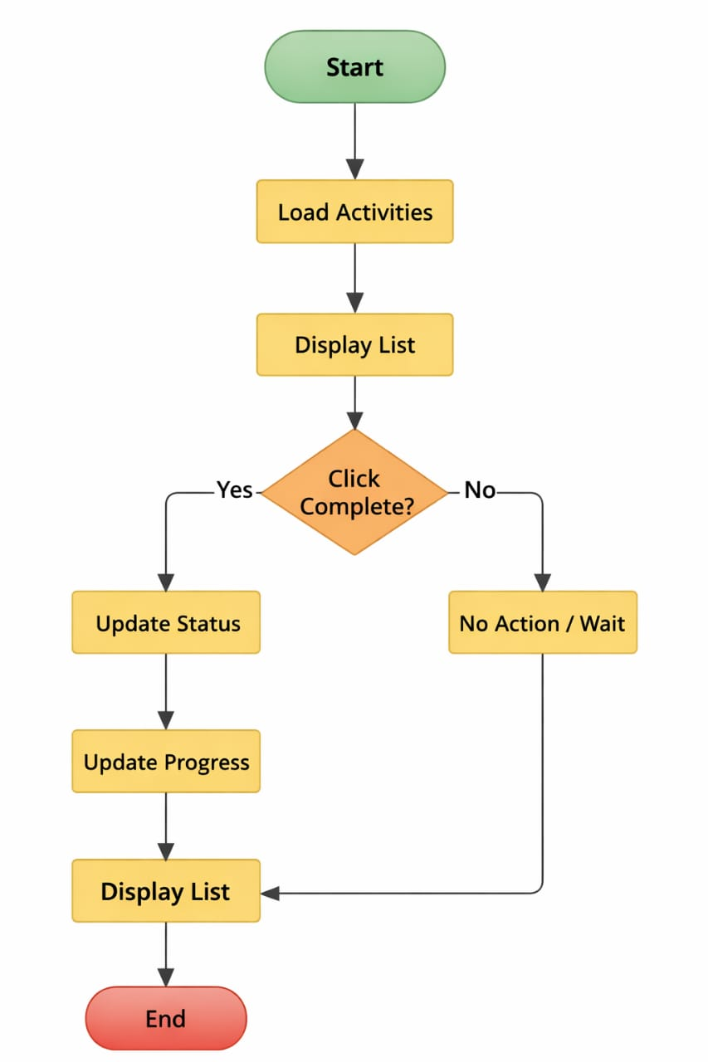



4. Data Handling Approach

The application uses an in-memory JavaScript array to store activity data. Each activity contains:
- Activity name
- Completion status (true/false)
Example: {name: "HTML Practice", completed: false}
Optionally, Local Storage can be used to save data so that progress is not lost after refreshing the page.

5. UI Components Design

The application UI is designed using simple and user-friendly components:
🔹 Activity List
Displays all activities dynamically using JavaScript DOM manipulation.
🔹 Action Controls
Buttons or checkboxes are provided for each activity to mark it as completed.
🔹 Progress Display
Shows the number of completed activities out of total activities (e.g., 2/4 completed).

6. Interactivity Implementation

Interactivity is implemented using JavaScript event handling.
- When the user clicks the “Complete” button
- The corresponding activity status changes from Pending to Completed
- The UI is updated dynamically using DOM manipulation
- No page reload is required
This ensures a smooth and responsive user experience.

7.CODING
1.INDEX.HTML

<!DOCTYPE html>
<html>
<head>
<title>Activity Tracker</title>
<link rel="stylesheet" href="style.css">
</head>
<body>

<h1>Activity Tracker</h1>

<p id="progress">0 out of 0 completed</p>

<ul id="activity List"></ul>

<script src="script.js"></script>
</body>
</html>

2.STYLE.CSS

body {
font-family: Arial;
text-align: center;
}

h1 {
color: darkblue;
}

ul {
list-style: none;
padding: 0;
}

li {
margin: 10px;
}

button {
margin-left: 10px;
padding: 5px 10px;
cursor: pointer;
}

3.SCRIPT.JS

// Activity Data (Array)
let activities = [
{name: "HTML Practice", completed: false},
{name: "CSS Styling", completed: false},
{name: "JavaScript Learning", completed: false},
{name: "Project Work", completed: false}
];

// Load Activities
function load Activities () {
let list = document.getElementById("activity List");
list.innerHTML = "";

activities.forEach((activity, index) => {
let li = document.createElement("li");

li.innerHTML = `
${activity.name} -
${activity.completed ? "Completed”: "Pending"}
<button onclick="markComplete(${index})">Complete</button>
`;

list.appendChild(li);
});

Update Progress ();
}

// Mark Activity Completed
function markComplete(index) {
activities[index]. completed = true;
loadActivities ();
}

// Update Progress
function updateProgress () {
let completedCount = activities.filter(a => a. completed). length;
let total = activities.length;

document.getElementById("progress"). innerText =
`${completed Count} out of ${total} completed`;
}

// Initial Load
loadActivities();

7. Application Logic
The application logic includes:
- Iterating through the activity list
- Updating the status of selected activity
- Counting completed activities using filter method
- Updating progress text dynamically
- Re-rendering the UI after every action
Example Logic:
- Total activities = 4
- Completed = 2
👉 Display → “2 out of 4 completed”

8. Technology Used

The following technologies are used:
- HTML → Structure of the web page
- CSS → Styling and layout design
- JavaScript → Logic, event handling, and DOM manipulation

9. Best Practices Followed
- Meaningful variable names (e.g., activities, completed Count)
- Modular functions (load Activities, update Progress)
- Avoided hardcoding values
- Added comments for readability
- Handled edge cases (e.g., all tasks completed)

10. Key Features Implemented

• Dynamic display of activities
• Mark activity as completed
• Real-time progress tracking
• Instant UI updates without reload
• Simple and clean user interface

11. Expected Output / Deliverables

The final output includes:
- A fully functional front-end Activity Tracker
- Interactive system to update activity status
- Real-time progress display
- Source code with proper file structure
- GitHub repository with README documentation

HTML
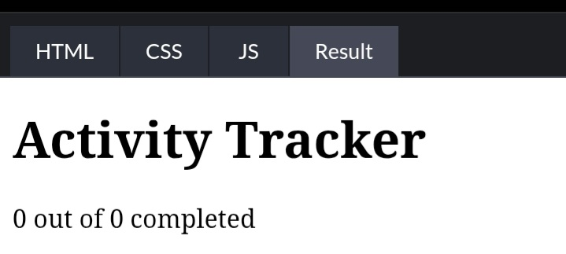

CSS
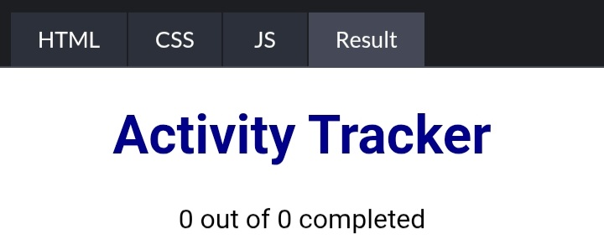

JAVA
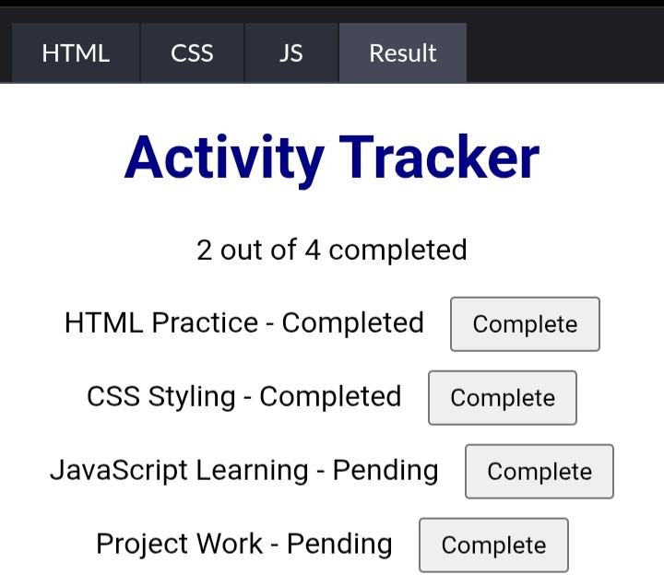

12. Learning Outcome

This project helps in understanding:
- JavaScript event handling
- DOM manipulation techniques
- State management using arrays
- Building interactive UI without backend

13. Conclusion

The project successfully converts a static interface into an interactive application. It allows users to manage activities efficiently with real-time updates. This demonstrates practical knowledge of front-end development and improves overall user experience.

